Python Journal

Q1) Write a program to determine if a given string is palindrome or not using combination of positive and negative indexing. Take the string as an input from the user.

-> String_Methods.py # file containing all the string methods  
def palindromeCheck(s):   
 s = s.lower() # converts the entered input into lowercase  
 isPalindrome = True # flag variable initially set to True  
 length = len(s) // 2   
# we take half the length of input since we need to match first half with second half  
 for i in range(length):  
 if s[i] != s[-(i + 1)]:   
# if the first and second half don't match, we make isPalindrome to False, thus indicating not a palindrome  
 isPalindrome = False  
 if isPalindrome:  
 print("Palindrome")  
 else:  
 print("Not a palindrome")

-> String_User_Input.py # file for taking user input as string  
from String_Methods import palindromeCheck # import file and its method  
string = input("Enter a string: ") # takes input from the user  
palindromeCheck(string) # function call

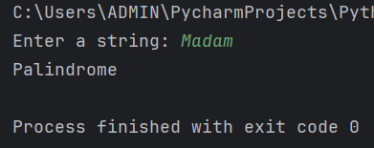  
Output:

Q2) Without using count() demonstrate the use of for loop to determine the number of occurences of a given character in a string. Take the string and character from the user.

-> String_Methods.py  
def occurencesOfChar(s, c):   
# method to check the occurences of character in a string  
 count = 0  
 for i in s:  
 if i == c:   
# if the occurence of character matches the index, we increment the count  
 count += 1  
 print(count)

-> String_User_Input.py  
from String_Methods import occurencesOfChar  
string = input("Enter a string: ") # takes input from the user  
ch = input("Enter a character: ")  
occurencesOfChar(string, ch) # function call

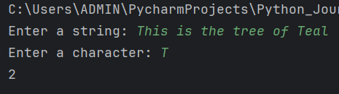  
Output:

Q3) Without using readymade methods, write a program to find factorial of a given number. Take the number from the user.

-> Integer_Methods.py # file containing all the integer methods  
def calculateFactorial(num): # method to calculate the factorial of a number  
 fact = 1  
 for i in range(1, num + 1):  
 fact = fact * i  
 print(f"The factorial of {num} is {fact}")

-> Integer_User_Input.py # file for taking user input as an integer  
from Integer_Methods import calculateFactorial  
n = int(input("Enter a number: ")) # takes input from the user  
calculateFactorial(n) # function call

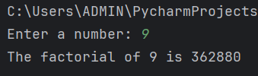  
Output:

Q4) Without using any readymade methods, write a program in Python to reverse the sequence of words in a given string. Take the string from the user.

-> String_Methods.py  
def reverseWords(string):   
# method to reverse the sequence of words in a string  
 st = string.split() # splits the words and creates a list  
 reverse_str = st[::-1] # reverse the order of words using indexing  
 output = ' '.join(reverse_str) # joins all the reverse words  
 print(output)

-> String_User_Input.py  
from String_Methods import reverseWords  
s = input("Enter a string: ") # takes input from the user  
reverseWords(s) # function call

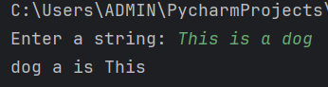  
Output:

Q5) Without using any readymade methods, write a program in Python to check if the given number is an Armstrong number or not. Take the number from the user.

-> Integer_Methods.py:  
def armstrongCheck(num):   
# method to check if the number is armstrong or not  
 temp = num   
# temporary variable which holds same value as the entered input  
 sum = 0  
 while num > 0:  
 rem = num % 10  
 sum = sum + (rem * rem * rem)  
 num = num // 10  
 if sum == temp:  
 print(f"{temp} is an Armstrong number")  
 else:  
 print(f"{temp} is not an Armstrong number")

-> Integer_User_Input.py  
from Integer_Methods import armstrongCheck  
n = int(input("Enter a number: ")) # takes input from the user  
armstrongCheck(n) # function call

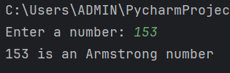  
Output:

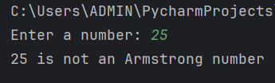

Q6) Without using readline() demonstrate a way in Python to read a multiline file line by line.

-> File_Methods.py # file containing all the file handling methods  
def readMultiLines(file):  
# method to read a multiline file line by line without using readlines()  
 try:  
 f = open(file)   
# opens the specified file in 'r' mode which is default mode f.seek(0) # starts the file pointer from 0 print(f"The contents of {file} are...") for i in f: print(i) # prints the contents line by line  
 except FileNotFoundError: # if file not found  
 print("File does not exist")

-> File_User_Input.py # file for taking user input as string (filename)  
from File_Methods import readMultiLines  
fname = input("Enter the file name: ")readMultiLines(fname)

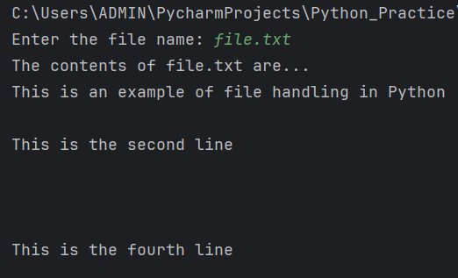  
Output:

Q7) Using readlines() demonstrate a way to return the total number of NON BLANK lines in a file.

-> File_Methods.py  
def nonBlankLines(file):  
# method to return the total number of non-blank lines in a file  
 try:  
 f = open(file)  
 lines = f.readlines() # reads all the lines from the specified file  
 count = 0  
 for i in lines:  
 if i.strip():   
# removes extra whitespaces thus returning only non-blank lines  
 count += 1  
 print(f"The number of non blank lines in {file} is {count}")  
 except FileNotFoundError: # if file not found  
 print("File does not exist")

-> File_User_Input.py  
from File_Methods import nonBlankLines  
fname = input("Enter the file name: ")  
nonBlankLines(fname)

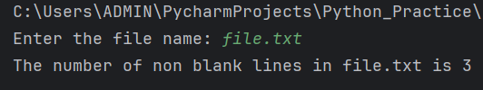  
Output:

Q8) Using file writing methods, write a message from the user in a file. Show use of write when the file is in 'w' mode and 'a' mode.

-> File_Methods.py  
def writeReadDemo(file, msg, ap_msg):  
# method to demonstrate the usage of 'w' and 'a' mode in file  
 try:  
 f = open(file, 'w') # opens the specified file in 'w' mode  
 f.write(msg) # writes the user defined message in the file  
 print("Content written successfully...")  
 f = open(file)  
 print(f.read()) # prints the contents of file after writing  
 f = open(file, 'a') # opens the specified file in 'a' mode  
 f.write(ap_msg)  
 print("Content appended successfully...")  
 f = open(file)  
 print(f.read())  
 except FileNotFoundError: # if file not found  
 print("File does not exist")

-> File_User_Input.py  
from File_Methods import writeReadDemo  
fname = input("Enter the file name: ")  
message = input("Enter the message to write in file: ")  
append_msg = input("Enter the message to append after writing: ")  
writeReadDemo(fname, message, append_msg)

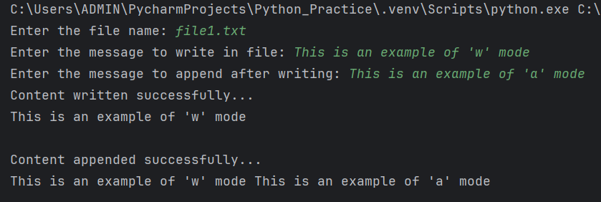  
Output:

Q9) Write a class Student having attributes, name, rollNumber, mathsMks, scienceMks and engMks. Use getters and setters for these attributes. Write another class Marksheet having the attributes totalMks and percentage. Define a method calculateMarks() and calculatePercentage(). Create a Student class object in Marksheet class. Assign name, roll number, maths, science and english marks to the student class object. Invoke calculateMarks() and calculatePercentage() using the data of this Student object.

-> class Student:  
 def __init__(self, name, rollNumber, mathsMks, scienceMks, engMks):  
 self._name = name # non-public attributes  
 self._rollNumber = rollNumber  
 self._mathsMks = mathsMks  
 self._scienceMks = scienceMks  
 self._engMks = engMks  
  
 def setName(self, name): # setter to set the value

if len(name.strip()) == 0:  
 print("Name field should not be empty.")  
 else:  
 self._name = name  
  
def getName(self): # getter to get the value  
 return self._name  
  
def setRollNumber(self, rollNumber):  
 if len(rollNumber.strip()) == 0:  
 print("Roll number should not be empty.")  
 else:  
 self._rollNumber = rollNumber  
  
def getRollNumber(self):  
 return self._rollNumber  
  
def setMathsMks(self, mathsMks):  
 if mathsMks < 0:  
 print("Math marks should not be negative.")  
 else:  
 self._mathsMks = mathsMks  
  
def getMathsMks(self):  
 return self._mathsMks  
  
def setScienceMks(self, scienceMks):  
 if scienceMks < 0:  
 print("Science marks should not be negative.")  
 else:  
 self._scienceMks = scienceMks  
  
def getScienceMks(self):  
 return self._scienceMks  
  
def setEngMks(self, engMks):  
 if engMks < 0:  
 print("English marks should not be negative.")  
 else:  
 self._engMks = engMks  
  
def getEngMks(self):  
 return self._engMks

-> from Student import Student  
# import Student class from Student.py  
class Marksheet:  
 def __init__(self):  
 self.totalMks = 0 # public attribute  
 self.percentage = 0  
  
   
 def calculateMarks(self, mathsMks, scienceMks, engMks):   
 # method to calculate total marks  
 self.totalMks = mathsMks + scienceMks + engMks  
 print(f"The total marks are {self.totalMks}")  
  
 def calculatePercentage(self): # method to calculate total percentage  
 self.percentage = (self.totalMks * 100) / 300  
 print(f"The percentage of the student is   
 {round(self.percentage, 2)}")  
  
student = Student("", "", 0, 0, 0)  
student.setName(input("Enter the student name: "))  
student.setRollNumber(input("Enter the roll number of the student: "))  
student.setMathsMks(int(input("Enter the maths marks: ")))  
student.setScienceMks(int(input("Enter the science marks: ")))  
student.setEngMks(int(input("Enter the english marks: ")))  
  
marks = Marksheet()  
marks.calculateMarks(student.getMathsMks(), student.getScienceMks(), student.getEngMks())  
marks.calculatePercentage()

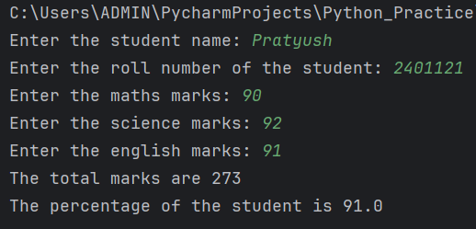Output:

Q10) Using the concept of class, public and non-public attributes and methods write a program to calculate the area of a rectangle.

-> class calculateAreaRect:  
 def __init__(self, length, width):  
 self.length = length # public attribute  
 self.width = width  
 self._area = 0.0 # non-public attribute  
  
 def _calculateArea(self): # non-public method  
 self._area = self.length * self.width  
  
 def getArea(self): # public method  
 self._calculateArea() # call the _calcualateArea method  
 return self._area # returns the area of the rectangle

-> Integer_User_Input.py  
from Calculate_Area_Rect import calculateAreaRect  
# take inputs from the user  
length = int(input("Enter the length of the rectangle: "))   
width = int(input("Enter the width of the rectangle: "))  
rec = calculateAreaRect(length, width)  
print(f"The area of the rectangle is {rec.getArea()}")

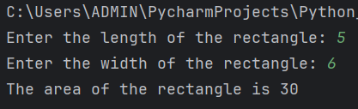Output:

Q11) Write a class Employee having attributes name, dept, sal. Add a method calculate_salary(). This method should calculate the salary using the logic, 30* 2000. Print the final salary calculated. Write a subclass SalesEmployee having attribute no_of_leads. Override calculate_salary() which uses the formula, salary = 30*2000*no_of_leads. Write another subclass ManufacturingEmployee having attribute no_of_extra_hours. Override calculate_salary which uses the formula, salary = 30*20*no_of_extra_hours. In a separate file, EmployeeSalary.py create objects of these classes and invoke their respective calculate_salary().

-> class Employee:  
 def __init__(self, name, dept, sal):  
 self.name = name # public attributes  
 self.dept = dept  
 self.sal = sal  
  
 def calculate_salary(self): # method to calculate salary  
 total_sal = 30 * self.sal  
 print(f"The total salary of the employee is {total_sal}")  
  
class SalesEmployee(Employee):  
 def __init__(self, name, dept, sal, no_of_leads):  
 super().__init__(name, dept, sal)   
 # call attributes of parent class using super()  
 self.no_of_leads = no_of_leads  
  
 def calculate_salary(self): # override calculate_salary method  
 total_sal = 30 * self.sal * self.no_of_leads  
 print(f"The total salary of the sales employee is {total_sal}")  
  
class ManufacturingEmployee(Employee):  
 def __init__(self, name, dept, sal, no_of_extra_hours):  
 super().__init__(name, dept, sal)  
 self.no_of_extra_hours = no_of_extra_hours  
 def calculate_salary(self):  
 total_sal = 30 * self.sal * self.no_of_extra_hours  
 print(f"The total salary of the manufacturing employee   
 is {total_sal}")

-> Employee_Salary.py  
from Employee import Employee, SalesEmployee, ManufacturingEmployee  
# Common user inputs  
name = input("Enter the name of the employee: ")  
dept = input("Enter the department of the employee: ")  
salary = int(input("Enter the base salary of the employee: "))  
# Dynamic user input based on type  
employee_type = input("Enter the type of employee (General/Sales/Manufacturing): ").lower()  
if employee_type == "sales": # for sales employee  
 no_of_leads = int(input("Enter the number of leads generated   
 by the employee: "))  
 sales_emp = SalesEmployee(name, dept, salary, no_of_leads)  
 sales_emp.calculate_salary()  
elif employee_type == "manufacturing": # for manufacturing employee  
 no_of_extra_hours = int(input("Enter the number of extra hours  
 worked by the employee: "))  
 manufacturing_emp = ManufacturingEmployee(name, dept, salary,  
 no_of_extra_hours)  
 manufacturing_emp.calculate_salary()  
else: # for general employee  
 emp = Employee(name, dept, salary)  
 emp.calculate_salary()

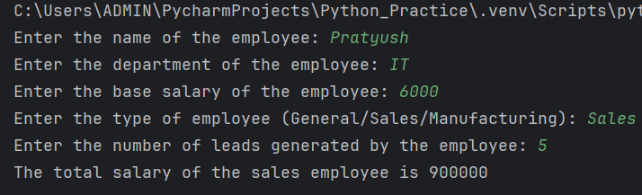Output: